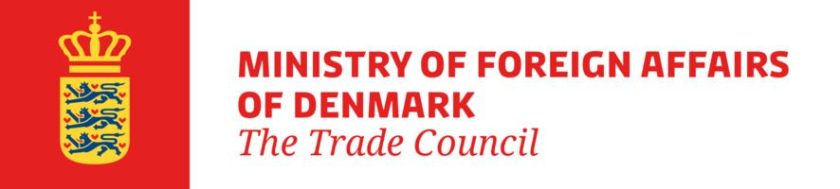
January 2026
Appendix 2
Subsidy Form Joint Trade Promotions
This trade promotion receives funding from The Trade Council (TC) under the programme “Joint Trade Promotions." The form must be completed by an authorised signatory from a company registered in Denmark with a CVR number. Companies that have not filled in the form, or that have not filled in the form correctly, will not be eligible for a grant. The form must also be completed by companies participating in the trade promotion without a grant.
Identification of the trade promotion (to be filled in by the coordinator):
Project title
Project manager
Project reference |  | Start and end dates of the event
The company commits to participate in the trade promotion in accordance with the guidelines for the "Joint Trade Promotions" programme, i.e. to be present and participate in presentations, contact meetings, etc. Only the Danish CVR registered company is eligible for a grant.
Be aware that after the trade promotion has been completed, the contact person below will be invited to participate in a satisfaction and outcome evaluation*.
Company information (to be filled in by the participating company)
Company name in Denmark: |  |  |  | CVR:
Address:
Zip code: | City:
Company type: |  |  |  | Company phone number:
Below, please provide, at group level, the number of employees and either turnover or balance sheet total for the latest financial
year.
Number of employees** | Turnover in million DKK** |  |  | Balance sheet in million DKK**
Purpose of company’s participation:

Does the company wish to receive de minimis aid? |  |  | Yes: |  | No:
If YES, how much de minimis aid has the company received over a rolling three-year period, including the current project***.
The date of allocation of de minimis aid is the same date as the date of signing this subsidy form.
Enter the amount in DKK:
Name of person participating in the trade promotion:
Direct email address:
The signatory, who is employed with and authorised by the above-mentioned company to apply for participation in the joint
trade promotion, declares that, to the best of their knowledge and belief, the information herein is true and complete****
and that the company is familiar with the EU's de minimis rules***.
Date: | Name of authorised signatory:
Signature:
* How the Ministry of Foreign Affairs processes personal data.
** A company is classified as an SME when the company has fewer than 250 employees at group level in the last financial year and a
turnover of no more than DKK 375 million and/or an annual balance sheet of no more than DKK 320 million. If the turnover or balance sheet exceeds DKK 375 million or DKK 320 million, respectively, and the company does not wish to disclose the exact turnover or
balance sheet, "more than DKK 375 million in turnover" or "more than DKK 320 million in balance sheet" can be stated. If the applicant is owned by a parent company with more than 49 % ownership and/or has subsidiaries with more than 49% ownership, the total number of employees and turnover for the entire group must be included. This also applies if the parent company itself is owned by another parent company with more than 49% ownership, regardless of whether the parent or subsidiary companies are based in Denmark or abroad.
*** According to the EU rules on de minimis aid as set out in the Commission's Regulation (EU) No 2023/2831 of 13 December 2023 on the application of Articles 107 and 108 of the Treaty on the Functioning of the European Union to de minimis aid, companies must not
receive de minimis aid at group level that exceeds the limit set by the de minimis regulation, i.e. EUR 300,000 over 3 years per member state. If the company is legally part of a group structure (domestic or international) that is interpreted as a single entity under the de minimis
regulation, the full amount for the entire group must be disclosed. If no aid has been received, this must be indicated in the "No" field.
**** According to Act no. 53 of 31 January 2001 on certain aspects of the activities of the Trade Council of Denmark, section 7(1), the following applies: "Unless a higher penalty is prescribed by other legislation, a fine shall be imposed on anyone who, in connection with an application for a grant, provides false or misleading information or withholds information of importance to the decision of a case."

