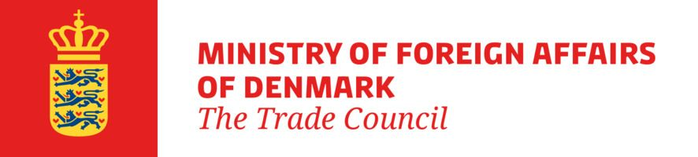
January 2024
Appendix 2
Subsidy Form Joint Trade Promotions
This trade promotion receives funding from The Trade Council (TC) under the programme “Joint Trade
Promotions". The form below must be completed by an authorised signatory from a company registered in
Denmark with a CVR number. Companies that have not filled in the form, or that have not filled in the form correctly, will not be able to participate in the trade promotion and will not be eligible for a grant. The form must also be completed by companies participating in the trade promotion without a grant.

Identification of the trade promotion (to be filled in by the coordinator):
Project title
Project manager
Project reference |  | Implementation dates
The company commits to participate in the trade promotion in accordance with the guidelines for the "Joint Trade Promotion" programme, i.e. to be present and participate in presentations, contact meetings, etc.
Only the Danish CVR registered company is eligible for subsidy. Be aware that after the trade promotion has been completed, the contact person below will be invited to participate in a satisfaction and outcome evaluation*.

Company information (to be filled in by the participating company)
Company name in Denmark: |  |  |  | Company registration number (CVR):
Address:
Zip code: | City:
Company type: |  |  |  | Company phone number:
Please specify the number of employees and turnover or balance sheet for the last financial year below:
Number of employees** | Turnover in million DKK** |  |  | Balance sheet in million DKK**
Does the company wish to receive “de minimis” aid? |  |  | Yes: |  | No:
If yes, how much de minimis aid has the company received in the current and the two previous financial
years, including the current project***. The date of allocation of de minimis aid is the same date as the date
of signing this subsidy form. Enter the amount in DKK:
Name of person participating in the trade promotion:
Direct email address:
The signatory, who is employed with and authorised by the above-mentioned company to apply for participation
in the joint trade promotion, declares that, to the best of their knowledge and belief, the information herein is
true and complete**** and that the company is familiar with the EU's de minimis rules.
Date: | Name of authorised signatory:
Signature:
* How the Ministry of Foreign Affairs processes personal data.
** A company is classified as an SME when the company has fewer than 250 employees at group level in the last financial year and a turnover of no more than DKK 375 million or an annual balance sheet of no more than DKK 320 million. If the turnover or balance sheet exceeds DKK 375 million or DKK 320 million, respectively, and the company does not wish to disclose the exact turnover or balance sheet, "more than DKK 375 million in turnover" or "more than DKK 320 million in balance sheet" can be stated.
*** According to the EU rules on de minimis aid as set out in the Commission's Regulation (EU) No 2023/2831 of 13 December 2023 on the application of Articles 107 and 108 of the Treaty on the Functioning of the European Union to de minimis aid. Companies must not receive de minimis aid at group level that exceeds the limit set by the de minimis regulation, i.e. EUR 300,000 over 3 financial years. If no aid has been received, this must be indicated in the "No" field.
**** According to Act no. 53 of 31 January 2001 on certain aspects of the activities of the Trade Council of Denmark, section 7(1), the following applies: "Unless a higher penalty is prescribed by other legislation, a fine shall be imposed on anyone who, in connection with an application for a grant, provides false or misleading information or withholds information of importance to the decision of a case."

